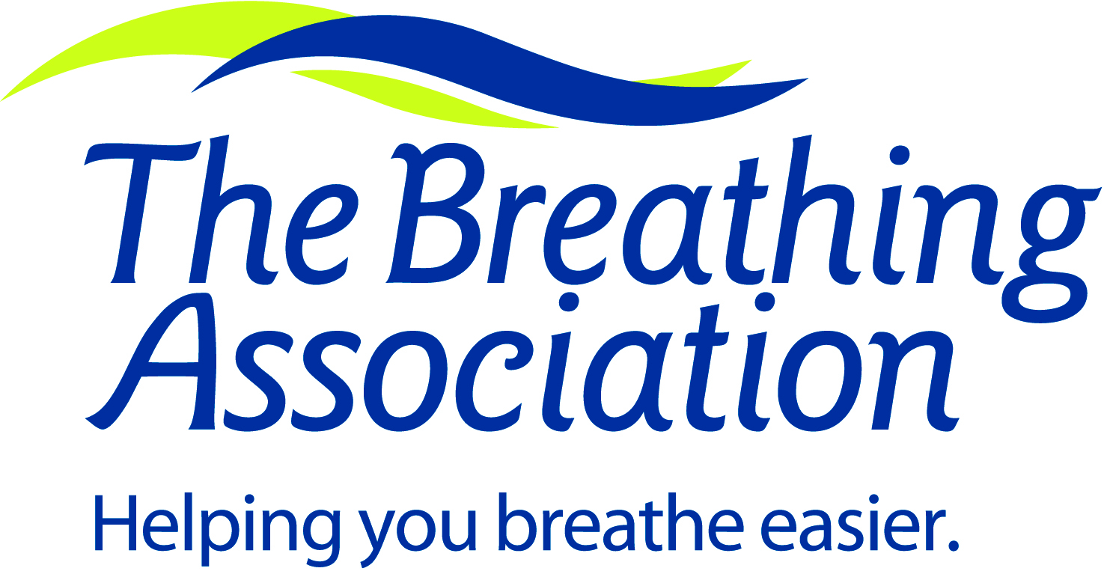
788 Mt. Vernon Ave.
Columbus, Ohio 43220
614-437-1521

(614) 437-1530

Tobacco Treatment Specialist Training Course
Statement of Work Experience

Name ___________________________________________________________________________________________

All applicants must complete this Statement of Work Experience.

Contact time in tobacco cessation patient care may be either prior to or subsequent to the Tobacco Treatment Specialist Training course. For those with a Bachelor’s degree or less, applicants should demonstrate a total of 480 hours of clinical activity related to tobacco cessation. Those with a graduate degree or post-Bachelor’s qualifications in a health-related field (e.g., advanced-practice nursing) should demonstrate 240 hours of patient care activity in tobacco cessation.

Please note: If these hours are not completed prior to the start of the TTS certification course, you will receive a Provisional Certification and you will have up to two years to complete the hours in order to receive Full Certification. If these hours are completed prior to the TTS Certification Course, and you pass the exam, you will receive Full Certification.

Please complete the grids below, beginning with your most recent work experience.

EXAMPLE:
Employer Name |  | The Best Clinic in Ohio
Dates Employed |  | March 2011 to Present
Title |  | Medical Social Worker
Supervisor’s Name |  | Suzie Supervisor
Tobacco Related Work Experience (please check all that apply):
“X” if applicable | Related Work Experience Description |  | Total # of Hours
x | Delivering direct patient care in tobacco cessation in group or individual counseling sessions, and/or telephone interventions and follow-up |  | 100
 | Teaching classes about tobacco cessation and related issues
 | Preparation time involved with cessation sessions or training classes
x | Supervision of other healthcare personnel who provide tobacco cessation services |  | 50
x | Other:  Pre-op meetings for patients going into surgery (along with surgery nurse) to prepare them for cessation post-surgery. |  | 90

Duplicate this page as needed for additional work experiences.

Employer Name
Dates Employed
Title
Supervisor’s Name
Tobacco Related Work Experience (please check all that apply):
X” if applicable | Related Work Experience Description |  | Total # of Hours
 | Delivering direct patient care in tobacco cessation in group or individual counseling sessions, and/or telephone interventions and follow-up
 | Teaching classes about tobacco cessation and related issues
 | Preparation time involved with cessation sessions or training classes
 | Supervision of other healthcare personnel who provide tobacco cessation services
 | Other:

Employer Name
Dates Employed
Title
Supervisor’s Name
Tobacco Related Work Experience (please check all that apply):
X” if applicable | Related Work Experience Description |  | Total # of Hours
 | Delivering direct patient care in tobacco cessation in group or individual counseling sessions, and/or telephone interventions and follow-up
 | Teaching classes about tobacco cessation and related issues
 | Preparation time involved with cessation sessions or training classes
 | Supervision of other healthcare personnel who provide tobacco cessation services
 | Other:

Cumulative Total Number of Hours from All Work Experience _________

My signature below indicates that the above listed information is accurate.

___________________________________________________________________________________________Signature Date

