C. E. BYRD HIGH SCHOOL OCTOBER 2, 2021 HOMECOMING DANCE CONTRACT

Cost: $20.00 PER TICKET Location: Byrd High School Time: 6:30 PM – 10:30 PM

Student must bring signed contract to the bookkeeper for access code activation. You may then purchase tickets @ https://www.locallevelevents.com/events/details/16978

Student’s Name: _________________________________________ Student Number ______________

Email __________________________________________ Phone _____________________

DANCE RULES

- Students currently expelled, suspended or in In-School Suspension are not allowed to attend the dance.
- Students will demonstrate good character and follow all school rules and Caddo Parish School Board Policies.
- Students will respect and be courteous toward all students and chaperones.
- Students need a contract to purchase tickets and must have an ID at the dance.
- Students may not sell or transfer tickets. Dance tickets are non-refundable.
- Students must be at the dance by 8:30 pm and may not exit and return to the dance.
- Students are subject to searches and/or random breathalyzer checks.
- Students must arrange to be picked up immediately after the dance.
- School dress code applies: This is a Semi-formal dance and students are to dress appropriately.
MEN: Slacks, dress shirts, suits, ties. Shirts must be worn throughout the dance.
LADIES: Semi-formal dress. Dresses should be tasteful.
PROHIBITED ITEMS: Jeans, hats, canes, sunglasses, fake tie shirts, sexually suggestive apparel.
- You will be on concrete, wear appropriate shoes. NO BARE FEET.

DANCING
Sexually explicit dancing (i.e. freaking, grinding, twerking or dirty dancing) and dancing that may result in disruption or injury are prohibited. Violators will be REMOVED from the dance and parents contacted.

BYRD HIGH SCHOOL STUDENT:
By signing, you agree that you will abide by the terms of the contract, and will comply with chaperone’s requests.

______________________________ _____________________________________ ___________
BYRD STUDENT SIGNATURE PRINTED NAME DATE

__________________________ _______________________________ __________
BYRD PARENT SIGNATURE PRINTED NAME DATE

- Access Code is student’s ID number without the beginning zero
- Tickets may be printed or scanned from your telephone at the door
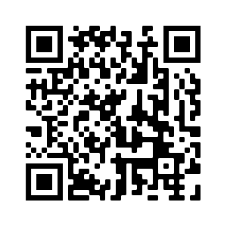
Bookkeeper Signature _______________________

