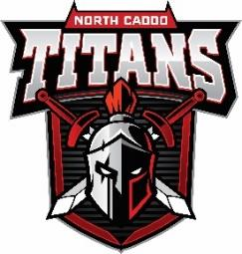
North Caddo Magnet High School
201 Airport Dr.
Vivian, LA 71082
Dance Guest Clearance Form

HOMECOMING: OCTOBER 8, 2022
Deadline to return completed form: SEPTEMBER 30, 2022

(please print all information legibly)

North Caddo Student’s Name: ____________________________ Date: ___________________

THIS IS TO VERIFY:
Name of Guest- _____________________________________________AGE__________________
Guest’s Home Address- _____________________________________________________________
Home Phone Number- ______________________________________________________________
IS ENROLLED AT- ________________________ NOT ENROLLED: ________________

Driver’s License #- ___________________________

Signature of Guest’s Administration- __________________________________________
Phone Number for Verification Purposes- ______________________________________

As a guest of North Caddo Magnet High School, you will be expected to abide by the following stipulations:
- All NCMHS AND CPSB rules apply to guests.
- Guests are to adhere to the dance dress code of NCMHS – a power point is available.
- Picture ID and tickets for both host and the guest are to be presented at the door upon arrival or there will be no admittance. There are no exceptions.
- Identification and tickets must be produced during the dance if requested by supervising personnel.
- White-out or any other type of altercations to this form are forbidden, and will invalidate this form.
- All guests are to enter the dance with the host student.
- The host student is to buy his/her guest’s ticket when purchasing his/ her ticket.
- Once you leave the dance, host and/or guest are not allowed to re-enter.
- No one over the age of 19 is allowed/ no middle school students are allowed.

I, ____________________________ (Guest Signature) understand that I must follow all of the stipulations as listed above.

I, ____________________________ (NCMHS Student Signature) understand that my guest is expected to abide by all rules as listed above.

_______________________________ __________________________________
Signature of NCMHS Student’s Parent Signature of NCMHS Administration

The Principal or Principal’s Designee reserve the right to deny or withdraw access from any person who will interfere with the peaceful conduct of school activities.

