

Dear Neighbors and Friends

As a lifetime resident of Greenlawn and alumni of Harborfields, I’m proud of the passionate efforts made by the volunteers in the Greenlawn Civic Association who dedicate countless hours to their town and help to make it the charming and welcoming village it is. It is important to remember that a magic wand and fairies are not responsible for the beautification projects that occur seasonally, such as the colorful plantings and hanging pots, the festive wreaths, American flags, antique lampposts, etc. In addition to the beautification projects that are implemented and maintained year round, the GCA also brings the community events like Earth Day, Ladies Night, and together with the Harborfields Library, The Longest Table. If you like what you have seen, imagine the possibilities that come with increased community involvement! After all, we all reap the benefits of the GCA’s work.

Several of our Brownie troops who attend Harborfields are excited to get involved with this wonderful organization. Protecting our planet and preserving our environment is going to be the main theme for the month of April. For example, we are learning ways that we can take action to protect our planet by reducing the waste and damage caused by plastic shopping bags. And how perfect that Earth Day is right around the corner. It’s a wonderful time to spread the message here in our town. And what a wonderful opportunity for our Brownie girls to learn the value of community service through their assistance with this fundraising project where they will help distribute limited-edition GCA shopping bags.

I am writing to you today as a Harborfields resident, a brownie troop leader and a member of the Greenlawn Civic Association.  We hope that your will show your support and hometown pride by purchasing one or more bag(s) today. Your purchase of a limited-edition canvas shopping tote will go to helping Greenlawn Civic Association. The cost is $15 for one bag or two bags for $25. 100% of the proceeds from the sales of the bags will go to supporting all of the important programs I mentioned above. Let’s help spread environmental awareness by replacing plastic with reusable, environmentally friendly canvas shopping bags when shopping around town. And thank you in advance for helping us teach our Brownie girls the value of community.

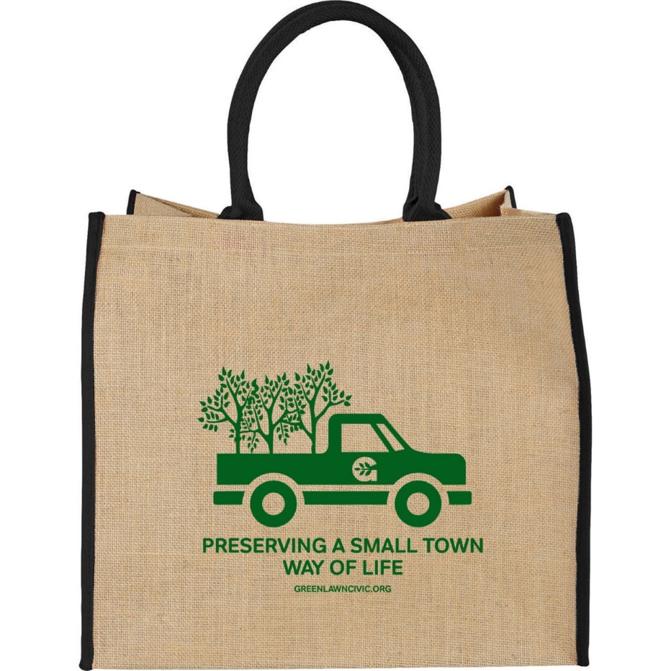

Tracy Goettinger