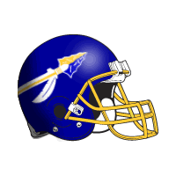
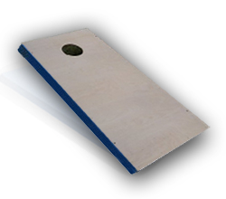
Olentangy Friends of Football presents…
The 3rd Annual Braves Cornhole Classic
and Meet the Coaches Day!

Saturday, August 19, 2017
The BREWZAA (The BREWZAA name will be changing this summer)
6477 Pullman Dr. Lewis Center 43035 (Kroger Plaza)
BREWZAA will be returning 10% of all food sales during the event back to Friends of Football!

Join the Olentangy High School Braves Coaching Staff in a day filled with friendly cornhole games! The top 4 winning teams will receive cash prizes. Raffle opportunities, along with the 50/50 cash prize, will be offered. Proceeds will support the Olentangy High School Football Program, with 25% of the net proceeds being donated to Special Olympics of Delaware County.

- Preregister your team by July 30th and receive a ¼ zip pullover. Preregister your team between July 31st – August 4th and receive a Braves Cornhole Classic t-shirt.
Deadline for guaranteed t-shirt is August 4th.
- **Day-of-play walk-up registrants welcomed.**
- Sign-in is 10:00-11:00, with games beginning at 12:00 p.m. Come early and warm up!
- ALL PLAYERS will receive raffle tickets for player-only door prizes.
- The cost per team is $80.
**To register online, visit Localevelevents (Online registration open until 11 pm on 8/18)
https://www.localevelevents.com/events/details/3156

If you are mailing your registration, please complete the form below and mail it with your check to:
Olentangy Friends of Football
Attn: Braves Cornhole Classic
P.O Box 6
Lewis Center, OH 43035
Please make checks payable to Olentangy Friends of Football.
For additional information, you are welcome to contact Mike Crotty at mcrotty@getspirit.com or Patty Murphy at davidmurphy@wowway.com .

Participants’ Names Participants’ emails Phone Numbers Shirt Sizes

____________________________ ____________________________ _________________ _________

____________________________ ____________________________ _________________ _________

TEAM NAME! ______________________________________________________________

