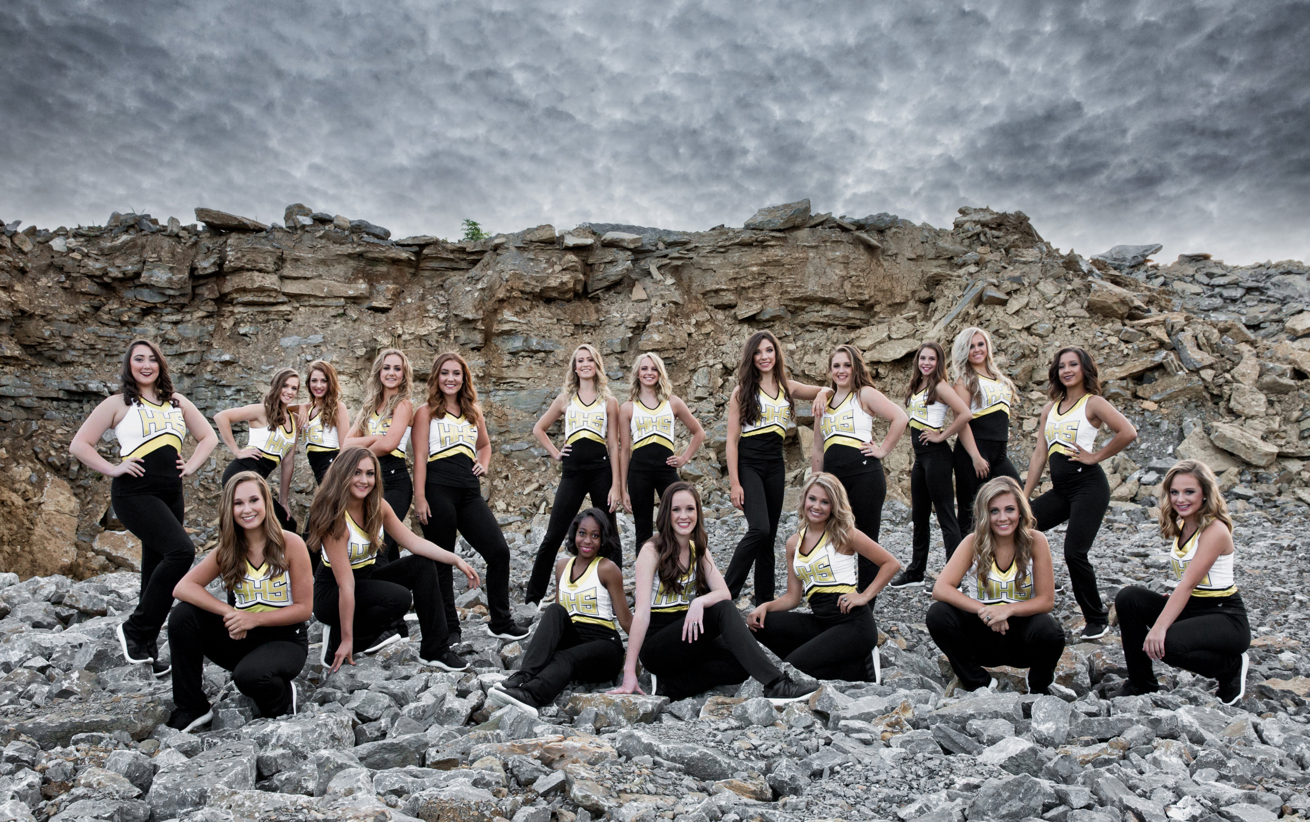  September 22, 2017  Calling ALL Golden Girls!  The 2017-2018 Golden Girls would like to invite you to join them for a night of fun, food, football and family!  The Day will begin with the Golden Girls performing at the Pep Rally in the HHS gym promptly at 9:30 a.m. Come cheer them on as they perform a special Homecoming Dance!  At 4:45 pm. All Golden Girls Past and Present will begin their walk around the HHS track to lead the Commandos to a victory!  Tailgating will begin at 5:15 p.m. serving a special steak and chicken game dinner for everyone to enjoy before the BIG Game! Each meal will be $10.00 per person with the Past Golden Girl receiving a free commemorative T-shirt to celebrate the day! Tailgate dinners and additional T-shirts may be purchased through www.localevelevents.com for any and all family members!  It will be a Homecoming to remember! Hope to see you there! | 9:30 a.m. at HHS  Pep Rally  ────  4:45 p.m. Homecoming Track Parade Line Up  ────  5:15 p.m. Tailgate Dinner is Served  ────  6:30 p.m. Homecoming Festivities at the Field  ────  Golden Girls  242 W. Main Street #119  Hendersonville, TN 37075  Jamie Jordan  615-289-9024

