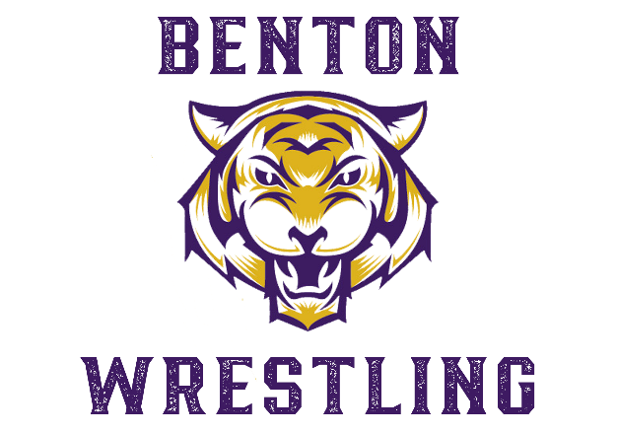

Dear Supporters of Benton High School Wrestling,

We are asking for your support to help the Benton High Wrestling team meet its budget for the 2024-2025 wrestling season. We believe that every Benton wrestler should have the proper equipment, transportation, and supportive coaching staff to help them succeed.

Our goal is to raise $8,000 in sponsorships. Some of the expenses expected this year include purchasing team gear, bus transportation, out-of-town travel expenses, and tournament fees.

As a sponsor, not only will you help cover these costs, you will help our wrestlers develop leadership skills, discipline, high self-esteem, and pride in themselves and our community.

Included in this letter are a variety of sponsorship packages for you to review. Thank you in advance for your generous contribution. If you have questions, please contact Coach Evans at (318) 759-2690 or [demontre.evans@bossierschools.org](mailto:demontre.evans@bossierschools.org).

Thank you for your support!

DeMontre Evans

DeMontre Evans

Head Coach

(Next page has sponsorship details)

Sponsorship Levels

**Bronze Sponsor - $100**

Bronze sponsors will have their company NAME placed on our 2024-2025 team's t-shirt & hoodie for advertisement.

**Silver Sponsor - $250**

Silver sponsors will have their company NAME & LOGO on our 2024-2025 team hoodies & t-shirts for advertisement.

**Gold Sponsor - $500**

Gold sponsors will have their company NAME & LOGO on our 2024-2025 team hoodies & t-shirts for advertisement (You will receive a Shirt). Your company name/logo will be placed on our social media pages once a month throughout the season.

**Platinum Sponsor - $1000**

Platinum sponsors will have their company name/logo on our 2024-2025 team hoodies & t-shirts for advertisement (You will receive a Shirt & Hoodie). Your company NAME & LOGO will be placed on our social media pages twice a month throughout the season. You will also have a custom pop-up banner for our home matches.

**\*\*Renewed Platinum Sponsor - $850**

**(Sponsors from the previous season**) Platinum sponsors will have their company name/logo on our 2024-2025 team hoodies & t-shirts for advertisement (You will receive a Shirt & Hoodie). Your company NAME & LOGO will be placed on our social media pages twice a month throughout the season. You will also have a custom pop-up banner for our home matches.

**Tiger Pride Sponsor - $1200**

Tiger Pride sponsors will have their company NAME & LOGO on our 2024-2025 team hoodies & t-shirts for advertisement (You will receive a Shirt & Hoodie). Your company NAME & LOGO will be placed on our social media pages twice a month throughout the season. You will also have a custom pop-up banner for our home matches & a sponsor custom flag outside for each wrestling event. Also free entry into any BHS Wrestling event.(1 Person Admission)

*All sponsors donating less than $100 will have their company name posted to our social media pages once at the beginning of the season, showing your support.*