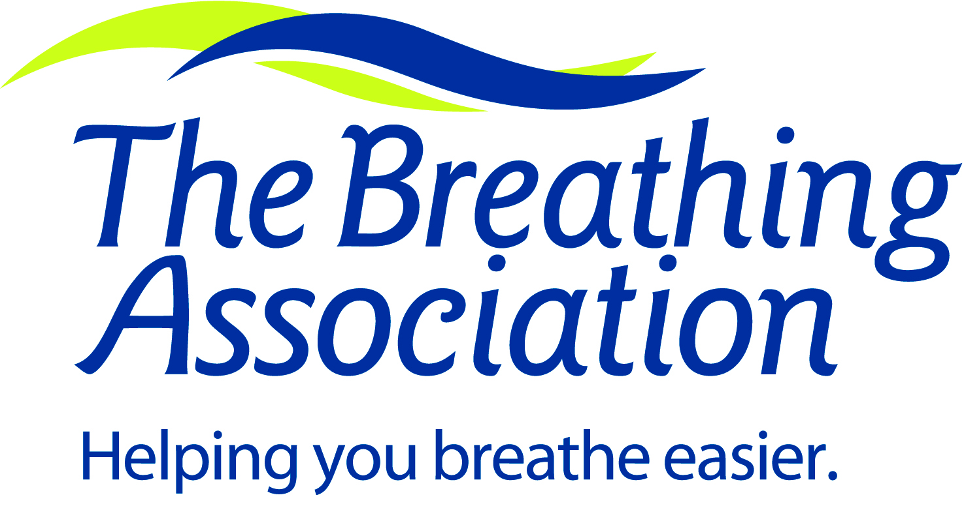
1520 Old Henderson Rd.
Columbus, Ohio 43220

(614) 437-1530

Tobacco Treatment Specialist Training Course
Statement of Work Experience

Name _____________________________________________________________________________________________________

All applicants must complete this Statement of Work Experience.

Contact time in tobacco cessation patient care may be either prior to or subsequent to the Tobacco Treatment Specialist Training course. For those with a Bachelor’s degree or less, applicants should demonstrate a total of 480 hours of clinical activity related to tobacco cessation. Those with a graduate degree or post-Bachelor’s qualifications in a health-related field (e.g., advanced-practice nursing) should demonstrate 240 hours of patient care activity in tobacco cessation.

Please note: If these hours are not completed prior to the start of the TTS certification course, you will receive a Provisional Certification and you will have up to two years to complete the hours in order to receive Full Certification. If these hours are completed prior to the TTS Certification Course, and you pass the exam, you will receive Full Certification.

Please complete the grids below, beginning with your most recent work experience.

EXAMPLE:
Employer Name |  | The Best Clinic in Ohio
Dates Employed |  | March 2011 to Present
Title |  | Medical Social Worker
Supervisor’s Name |  | Suzie Supervisor
Tobacco Related Work Experience (please check all that apply):
“X” if applicable | Related Work Experience Description |  | Total # of Hours
x | Delivering direct patient care in tobacco cessation in group or individual counseling sessions, and/or telephone interventions and follow-up |  | 100
 | Teaching classes about tobacco cessation and related issues
 | Preparation time involved with cessation sessions or training classes
x | Supervision of other healthcare personnel who provide tobacco cessation services |  | 50
x | Other:  Pre-op meetings for patients going into surgery (along with surgery nurse) to prepare them for cessation post-surgery. |  | 90
Duplicate this page as needed for additional work experiences.

Employer Name
Dates Employed
Title
Supervisor’s Name
Tobacco Related Work Experience (please check all that apply):
X” if applicable | Related Work Experience Description |  | Total # of Hours
 | Delivering direct patient care in tobacco cessation in group or individual counseling sessions, and/or telephone interventions and follow-up
 | Teaching classes about tobacco cessation and related issues
 | Preparation time involved with cessation sessions or training classes
 | Supervision of other healthcare personnel who provide tobacco cessation services
 | Other:

Employer Name
Dates Employed
Title
Supervisor’s Name
Tobacco Related Work Experience (please check all that apply):
X” if applicable | Related Work Experience Description |  | Total # of Hours
 | Delivering direct patient care in tobacco cessation in group or individual counseling sessions, and/or telephone interventions and follow-up
 | Teaching classes about tobacco cessation and related issues
 | Preparation time involved with cessation sessions or training classes
 | Supervision of other healthcare personnel who provide tobacco cessation services
 | Other:

Cumulative Total Number of Hours from All Work Experience _________

My signature below indicates that the above listed information is accurate.

____________________________________________________________________________________________________
Signature Date

Day | Time | Hours | Session | Faculty
Monday | 8:30 to 9:00 |  | Welcome and Introductions | Tom Houston
Monday | 9:00 to 10:00 | 1 | Tobacco Dependence Knowledge and Education: The Crisis | Tom Houston
Monday | 10:00 to 10:15 |  | BREAK
Monday | 10:15 to 12:00 | 1.75 | Tobacco Dependence Knowledge and Education: A Chronic Disease | Tom Houston
Monday | 12:00 to 1:00 |  | LUNCH ON YOUR OWN
Monday | 1:00 to 2:00 | 1 | Diversity and Cultural Issues | Chizimuzo Okoli
Monday | 2:00 to 4:00 | 2 | Diversity: Tobacco and Mental Health or Substance Use Disorder | Chizimuzo Okoli
Monday | 4:00-4:15 |  | BREAK
Monday | 4:15-5:00 |  | Homework Assignment and Discussion | Hammond/Houston
6.75
Tuesday | 8:00 to 9:30 | 1.5 | Smokeless Tobacco and Environmental Tobacco Smoke | Tom Houston
Tuesday | 9:30 to 9:45 |  | BREAK/Discussion Time
Tuesday | 9:45 to 11:45 | 2 | Counseling Skills: Motivational Interviewing | Gretchen Clark Hammond
Tuesday | 11:45 to 12:45 |  | LUNCH PROVIDED: Homework Review
Tuesday | 12:45 to 2:30 | 1.75 | Counseling Skills: Motivational Interviewing | Gretchen Clark Hammond
Tuesday | 2:30-2:45 |  | BREAK
Tuesday | 2:45-4:15 | 1.5 | Motivational Interviewing Practice | Gretchen Clark Hammond
Tuesday | 4:15 to 5:00 |  | Q and A | Hammond/Houston
6.75
Wednesday | 8:00 to 10:00 | 2 | Pharmacotherapies for Tobacco Addictions: Part I | Tom Houston
Wednesday | 10:00 to 10:15 |  | BREAK/Discussion Time
Wednesday | 10:15 to 12:00 | 1.75 | Neurobiology (Pharmacotherapies for Tobacco Addictions: Part II) | Tom Houston
Wednesday | 12:00 to 1:00 |  | LUNCH ON YOUR OWN
Wednesday | 1:00 to 2:00 | 1 | Diversity: and Specific Health Issues with Women | Tom Houston
Wednesday | 2:00 to 5:00 | 3 | Assessment Interview | Gretchen Clark Hammond
Wednesday | 5:00 to 5:30 |  | Homework Review | Hammond/Houston
7.75
Thursday | 8:00 to 10:00 | 2 | Treatment Planning | Gretchen Clark Hammond
Thursday | 10:00 to 10:15 |  | BREAK/Discussion Time
Thursday | 10:15 to 11:30 | 1.25 | Conducting Group Sessions | Gretchen Clark Hammond
Thursday | 11:30 to 12:30 |  | LUNCH PROVIDED: Homework Review
Thursday | 12:30-2:30 | 2 | Relapse Prevention | Gretchen Clark Hammond
Thursday | 2:30 to 2:45 |  | BREAK/Discussion Time
Thursday | 2:45 to 4:00 |  | Final Discussion/Course Wrap-UP | Hammond/Houston
5.25
Online | 2 | Professional Development/Professional Resources |  | Gretchen Clark Hammond
Online | 1 | Law and Ethics |  | Gretchen Clark Hammond
Online | 1.5 | Documentation |  | Chizimuzo Okoli
4.5
Total Hours for Continuing Education Credits: 30.00

