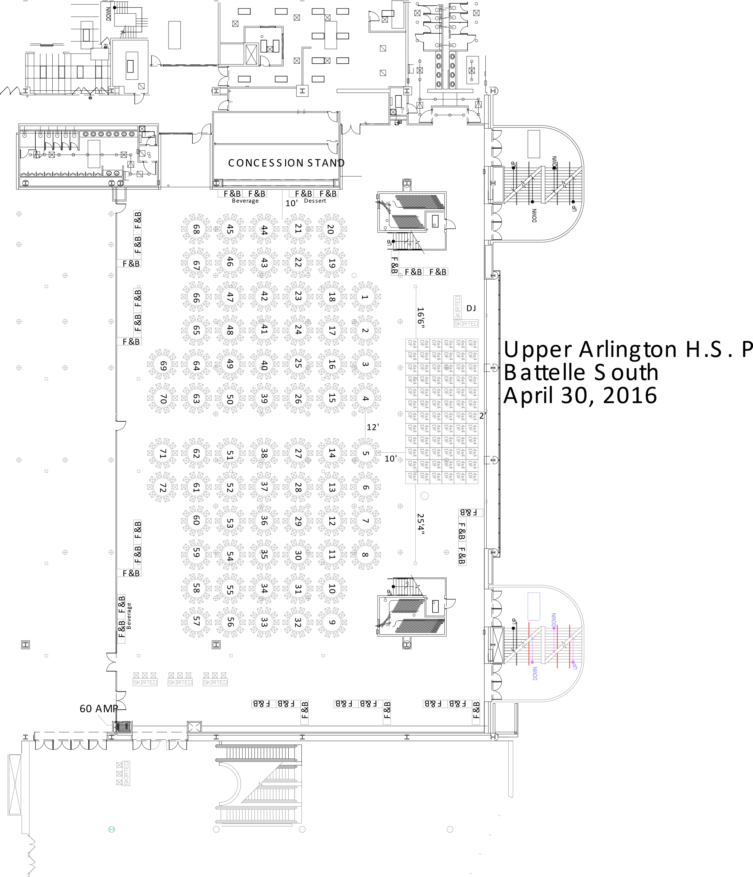

Upper Arlington Prom Dinner Menu
Grand Battelle Ballroom at the Greater Columbus Convention Center
Saturday, April 21, 2018 7:00 to 11:00pm

Appetizer
Dark Chocolate Fountain w/
Pineapple, Fresh Strawberries, Pretzel Rods & Marshmallows

Dinner Menu
Salad Bonanza
w/ Romaine, Spinach, Spring Mix, Shredded Carrots, Cucumbers, Croutons,
Bleu Cheese, Shredded Parmesan & Cheddar Cheese, Crispy Bacon, Hard cooked Eggs
White Balsamic, Raspberry Vinaigrette, Low Fat Italian and Buttermilk Ranch

Colossal Nachos
w/Corn Tortilla Chips, Chicken, Cheddar, Ground Beef, Pulled Pork, Sour Cream, Diced Tomato, Guacamole, Avocados, Sliced Black Olives, Jalapenos, Scallions, & Spicy Queso

Pasta Istle
Classic Penne, Bowtie, Butternut Ravioli
Marinara, Alfredo, Bolognese, Parmesan, Grilled Chicken, Roasted Seasonal Vegetables
DeCaprio’s Bounty of Bread

Mac and Cheese
Classic Made Mac & Cheese
Buffalo Chicken, Pulled Pork, Ground Chorizo, Bacon, Bleu Cheese, Cheddar Cheese, Cheetos Crumble, Tortilla Chips & BBQ Potato Chips

Slider Bar
Classic American, Mushroom Swiss, Bocca-Feta, or Fried Green Tomatoes
Traditional Accompaniments, Baked Beans & Celery Seed Slaw
Spice Rubbed, White Cheddar & Classic Housemade Chips,
with French Onion, Bleu Cheese & Avocado Ranch Dips

Gyro Station
Pita, Beef & Chicken, Shaved Lettuce, Diced Tomatoes, Red Onion, Tzatziki Sauce

Tots a Palooza
Trio of House Made Tots, with Ketchup, Mustard, & Cheese Sauce

Dessert
Build Your Own Ice Cream Sandwich
Assorted Cookies, Ice Creams and Toppings

Freshly Brewed Iced Tea, Freshly Brewed Coffee, and Ice Water

