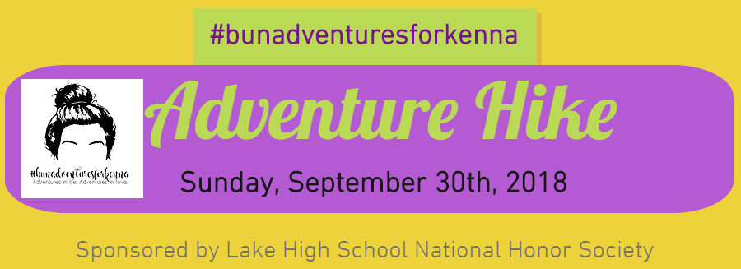​

Join us Sunday, September 30th, 2018 for a 3 mile Adventure Hike and Family Fun, followed by ice cream sundaes and live music! ​

Hike will begin at 3:00 PM. Registration pick-up will open at 2:30 PM.
Whetstone Event Center 8009 Beeson St. Louisville, Oh 44641
Registration is $20 per person, $10 for children 10 and under
Any questions? Contact Jackie Wolf at wolfjackie@lakelocal.org
Most of you know that Makenna Karmie was a beautiful girl who loved Jesus and loved people deeply. What you may not have known is that she also loved her messy high bun and beautifully manicured brows...and adventures.
Makenna had a love for sharing Jesus and loving people, even those who could be difficult to love. When questioned why she would venture to love others, she simply answered, "If not me, who?" Makenna felt a pull to love and provide for the homeless, often handing out gift cards and personal care items to those she encountered.​
The proceeds from this event will be used to purchase gift cards and personal care items. The Lake Local High School National Honor Society students will then assemble care bags to distribute to those in need.
​

----------------------------------------------------------------------------------------------------------------------------------------------------------------
Registration Form

Name ________________________________________________________ Age if under age 10________________

T-Shirt Size: Check one
Youth M Youth L Adult S Adult M Adult L Adult XL Adult XXL

Relative of Makenna? Yes No

Phone number: __________________________________ email address:__________________________________
Make Checks payable to: Lake Local Schools
Mail Registrations to: Jackie Wolf
1195 Marigold St. NW Hartville OH 44632

