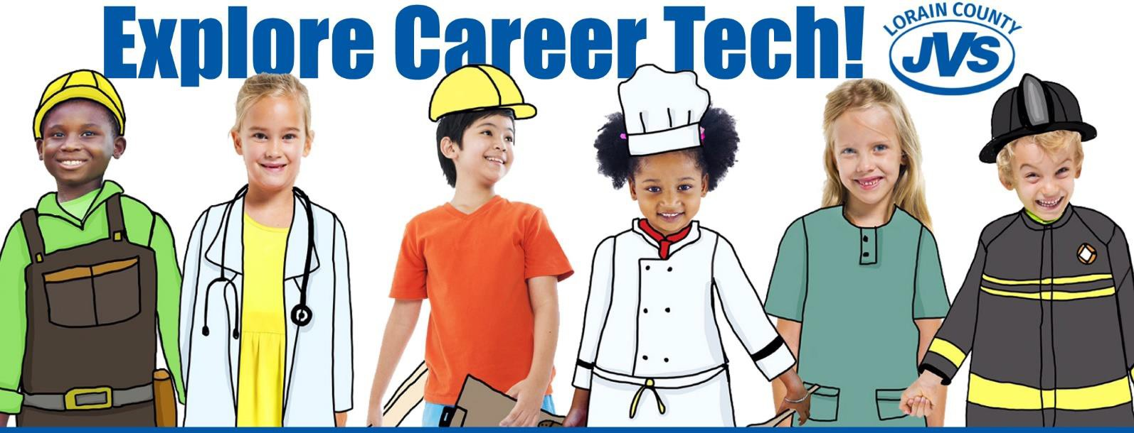
CAREER TECH SATURDAY

March 30, 2019
9:00 AM – 11:30 AM
(Door open at 8:30 AM)

Career Tech Lab Options For 4th, 5th & 6th Graders:

SOLD OUT “How Does My Garden Grow?” (Landscape & Greenhouse Management)
In our Landscape & Greenhouse Management Lab, you will make and take home a terrarium and plant seeds using a self-contained hydroponic system. You will see how vegetables are grown and make a salad too! You will take home your terrarium and hydroponic system to enjoy!

SOLD OUT “Tires Under Pressure!” (Auto Technology)
In our Auto Technology Lab, you will change a tire by only using tools provided by the car itself; check tire pressure and car fluids! You will use computers to talk to the car to give it a check-up! Take home a reminder of all the things you learned about cars!

SOLD OUT “Meant for Cement!” (Masonry)
In our Masonry Tech Lab, you will mix, pour, mold, and bedazzle a personalized cement garden stone to
place at home in your flowerbed or garden!

SOLD OUT “Manufacturing Madness!” (Precision Machine Technology)
In our Precision Machine Tech Lab, you will learn how to program a machine to create your own personalized dog tags! You will also sharpen a JVS pencil on the biggest pencil sharpener ever! Well, we know it as the Emco PC 55 CNC Lathe!

SOLD OUT “Birdhouse Builders!” (Carpentry)
In our Carpentry Tech Lab, you will use tools of the trade to construct, assemble, and personalize your own birdhouse or toolbox! You will take your creation home with you to share with your family!

SOLD OUT “STEM Magic in the Sand!” (Computerized Design & Drafting)
In our Computerized Design & Drafting Lab, you will make Magic Aqua Sand in jars. This engineering project combines STEM learning with art and shows chemical reactions to different materials when combined. Students will design underwater sand sculptures in jars to take home!

SOLD OUT “Stretch-Arm-Strong!” (Sports, Health & Fitness Technology)
In our Sports, Health and Fitness Technology Lab, learn about the importance of stretching on the body and how it affects athletic ability. Proper form and execution of static stretches will be taught as well as the connection between flexibility and the muscular system!

SOLD OUT “Metaling Mania” (Heating and Air Conditioning-HVAC)
In our Heating and Air Conditioning Lab, you will transfer a picture onto sheet metal. Students will also get a chance to work with the revolutionary Pex tubing and fittings.

SOLD OUT “Mirror, Mirror, on the Wall!” (Cosmetology)
You’re the fairest of them in our Cosmetology Lab. Students will get firsthand experience with Cosmetology services like manicuring and hair styling plus a little spa time for themselves.

SOLD OUT “PC Discovery!” (Network Communications Technology)
In our Network Communications Technology Lab, you will be familiarized with field replaceable units and learn to assemble them. You will also learn about Ethernet cable types and router settings!

SOLD OUT “Auto Art” (Collision Repair)
In our Collision Repair Lab, you will find your passion and artistic skills in spray and airbrush painting. You will also learn to mix colors, stencil and use brushes for shading and outlining.

SOLD OUT “Somewhere Over the Rainbow-Bread!” (Culinary Arts)
In the Culinary Arts lab, you will experience the colorful art of baking rainbow bread and the creative skills of building the ultimate sandwich.

SOLD OUT “Kid & Play!” (Early Childhood Education)
In the Early Childhood Education Lab, you will explore and experience firsthand the fun activities designed for younger children and the purpose behind those activities that you can conduct with younger siblings or even as a babysitter in the future.

*Programs that are sold out will be removed from registration

