2019 OLENTANGY BRAVES
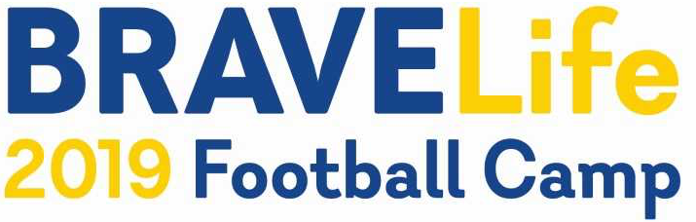
BRAVELife FOOTBALL CAMP
(an adapted camp for students with special needs)
K-12th GRADES
^{bravelifecamp@gmail.com}
WHO: Any student with special needs entering K-12th grades in the 2019/2020 school year
WHERE: Olentangy Braves Stadium – 675 Lewis Center Rd., Lewis Center, OH
WHEN: Wednesday, July 31st
TIME: 4pm -6:30pm with a cookout from 6:30-7:30
COST: FREE (Includes BRAVELife Football Camp T-Shirt and Cookout)
DRESS: T-shirt, shorts, and cleats or tennis shoes

This adapted camp is designed to provide students with special needs the opportunity to become Olentangy Football players for a day, while making connections and developing friendships. This camp was developed and will be lead by the 2019 Olentangy Braves football players and coaches. Come run through the Olentangy Braves football tunnel, tackle the tackling dummies, catch, pass and kick, score touchdowns, do an endzone dance, and have a great time on Braves Field. Join the team for a cookout following the camp beginning at 6:30. A parent/caregiver is welcome to join the BRAVELIfe camper if desired.
REGISTER: online at https://www.locallevelevents.com/events/details/7160 Registration DEADLINE: July 14th (to assure correct T-shirt sizes) – If you register after this date, we cannot guarantee correct sizes and/or shirt availablity Registration is limited to the first 100 students.
Registration forms should to be completed and mailed to: Olentangy Football, P.O. Box 443, Lewis Center, Ohio 43035 (ATTN: Braves Youth TEAM CAMP).
We are unable to accommodate all food allergies. Please pack food for the cookout if your camper has food allergies.
cut and keep the top portion for your records
----------------------------------------------------------------------------------------------------------------------------------------------------------------
BRAVELife Camp Registration PLEASE PRINT
Player Name ________________________________________________Grade (2019-2020) _______________________
Address _________________________________________________City______________________Zip_______________
1st Parent/Guardian ___________________________________________Cell #__________________________________
E-mail _________________________________________
2nd Parent/Guardian ___________________________________________Cell # _________________________________
E-mail _________________________________________
Important information about the BRAVELife camper: (allergies, medical concerns, ambulatory concerns, etc.)
__________________________________________________________________________________________________
Player Shirt Size (circle one): YS YM YL AS AM AL AXL AXXL
I authorize the director of the camp to act for me in any medical emergency. I hereby release, exonerate and discharge the camp and their employees from any or all actions or causes of actions known from any injuries incurred in camp or on the way to or from camp. I have medical coverage and will be responsible for any medial charges related to his/her attendance at camp. I give my child permission to attend the Olentangy BRAVELife Football Camp

________________________________________________________
Parent’s Signature Date

