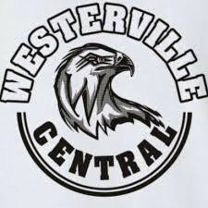
Hoops with the Hawks 2020
Westerville Central Athletic Boosters
Saturday, March 14, 2020 6:00 pm to 12:00 am
Star Lanes Polaris

8655 Lyra Drive, Columbus, Ohio 43240
Food, Bowling, Games, Big Screen Televisions for watching your favorite teams Silent auction, raffles……..Come join the party

Name  $30/Ticket |  | attending (Y/N) |  | # of squares Total  @ $5/square Tickets + Squares
Ex: | John Doe |  | Y |  | 4 = $20 | $30 + $20 = $50
1. |  |  | Y or N |  |  | $
2. |  |  | Y or N |  |  | $
3. |  |  | Y or N |  |  | $
4. |  |  | Y or N |  |  | $
5. |  |  | Y or N |  |  | $
6. |  |  | Y or N |  |  | $
7. |  |  | Y or N |  |  | $
8. |  |  | Y or N |  |  | $
9. |  |  | Y or N |  |  | $
10. |  |  | Y or N |  |  | $
11. |  |  | Y or N |  |  | $
12. |  |  | Y or N |  |  | $
13. |  |  | Y or N |  |  | $
14. |  |  | Y or N |  |  | $
Squares Game: Everyone who buys a square will have 2 chances to win. Squares will pay off at half-time and end of game for 4 games. The numbers on the sheet will be drawn randomly (0-9) and placed on the sheet. Names will be placed in a hat and drawn randomly and the boxes will be filled starting in the top left corner and going across in a snake-like path until the page is filled. This will continue until all of the names have been placed on the sheet. Any questions about the Squares game can be directed to Dan Shoemaker at 614-530-9497.

Fundraiser Rep: Sport Girls or Boys

Please make checks payable to WCABC

Please return this order form along with payment to your Athletic fundraiser rep. by Feb. 19th

