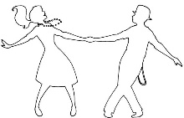
Winter Formal

CAHS WINTER FORMAL
GUEST PERMISSION SLIP

Crowne Plaza - Downtown
33 E. Nationwide Blvd
COLUMBUS, OH

Saturday, February 1, 2020
7:00 P.M. TO 10:00 P.M.

PLEASE PRINT CLEARLY

CAHS Student________________________________________________________________________

CAHS Student Phone_____________________________________________________________

Guest Name____________________________________________________________________

Guest School________________________________________________________________________

Guest Building Principal__________________________________________________________

Guest Parent Guardian____________________________________________________________

Guest Emergency Contact___________________________Phone_________________________

Mr. Sanders, Principal _______________________________________________________

